General Information and Connections

Table des matières
1 Control & connections 2
1.1 CNC Shield Guide 3
1.2 Stepper Motor 4
1.2.1 Connections 5
1.3 Motor Driver DRV8824 - DRV8825 5
1.3.1 Step Resolution Jumpers 6
1.4 Servo 7
1.4.1 Servo program features 7
2 Limit Switches 8
2.1 Connections 8
2.2 Filtering 10
3 Push buttons 11
3.1 Connections 11
3.2 Actions 13
4 Limit Switches 14
4.1 Enabling 14
4.2 Reached 15
5 UGcode-sender 15
6 Setting the Steps per mm 16

Control & connections

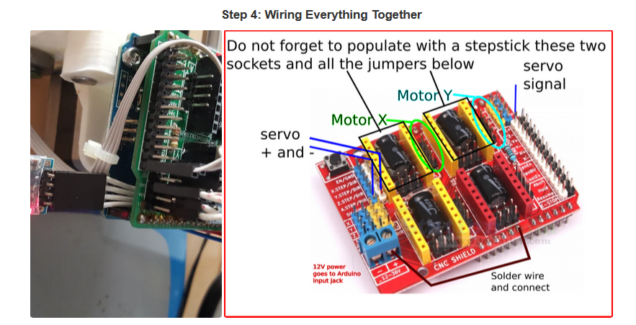
File : https://www.instructables.com/4xiDraw/

Before inserting the CNCShield over the Arduino you want to do this trick, that will allow to power everything from the Arduino power jack. Failing to do this connection from Vin to + header on CNCShield most likely will make your servo not to work properly.
On top of Arduino you insert the CNCShield board and on top of it, two of the Pololu StepStick stepper driver boards. But before inserting these two boards for axis X and Y, make sure you put three jumpers in the headers (that will later be obstructed by the Pololu carrier boards).
Two four-wire cables come from the stepper motors.
Each stepper motor goes to X and Y axis four pin headers on the CNCShield.
There is an optional improvement: make the plotter wireless by adding a Bluetooth module, but I would only do this once everything else is up and running.

CNC Shield Guide

File : CNC-Shield-Guide-v1.0.pdf

Below is a general outline process for connection of the various components:
- Taking normal static electricity precautions, insert the CNC Shield into the Arduino Uno making sure the correct pins of the CNC Shield are inserted into the correct UNO headers.
- Decide on the micro stepper setting for your application and place the jumpers as required

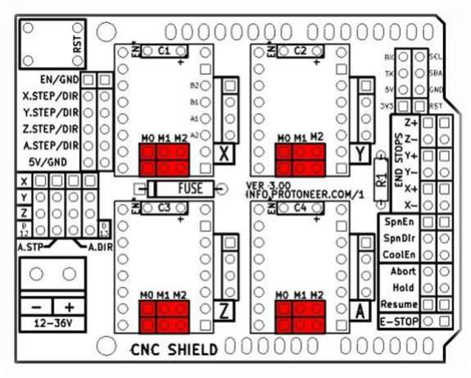
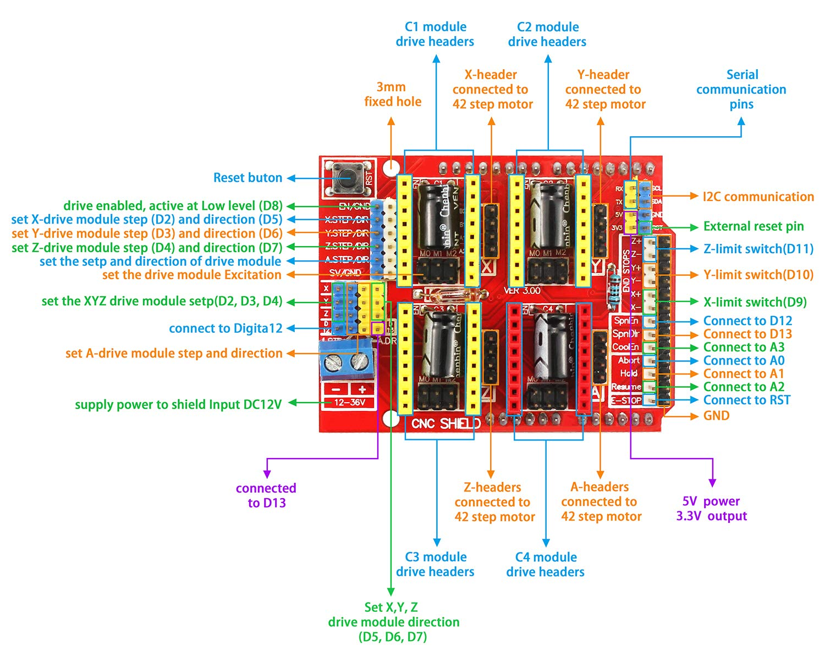

Stepper Motor
Stepper Motor NEMA17
File : NEMA17-schneider.pdf
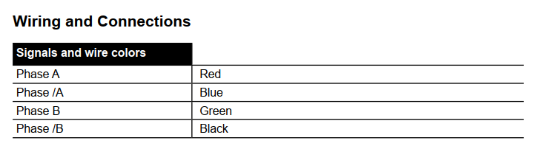
Stepper Motor 42SHD0001
File : 42SHD0001.jpeg

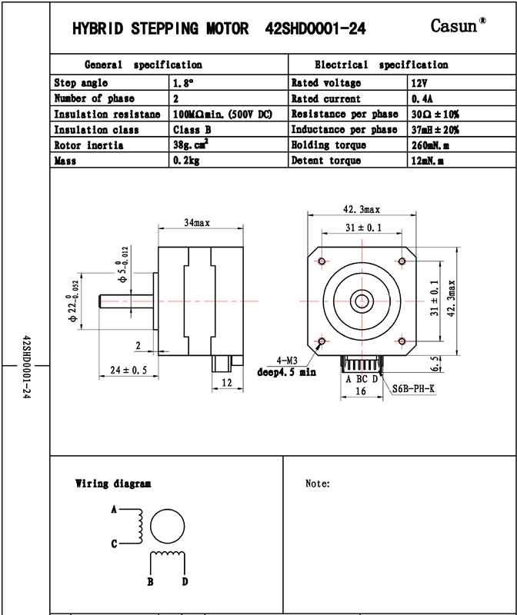

Connections

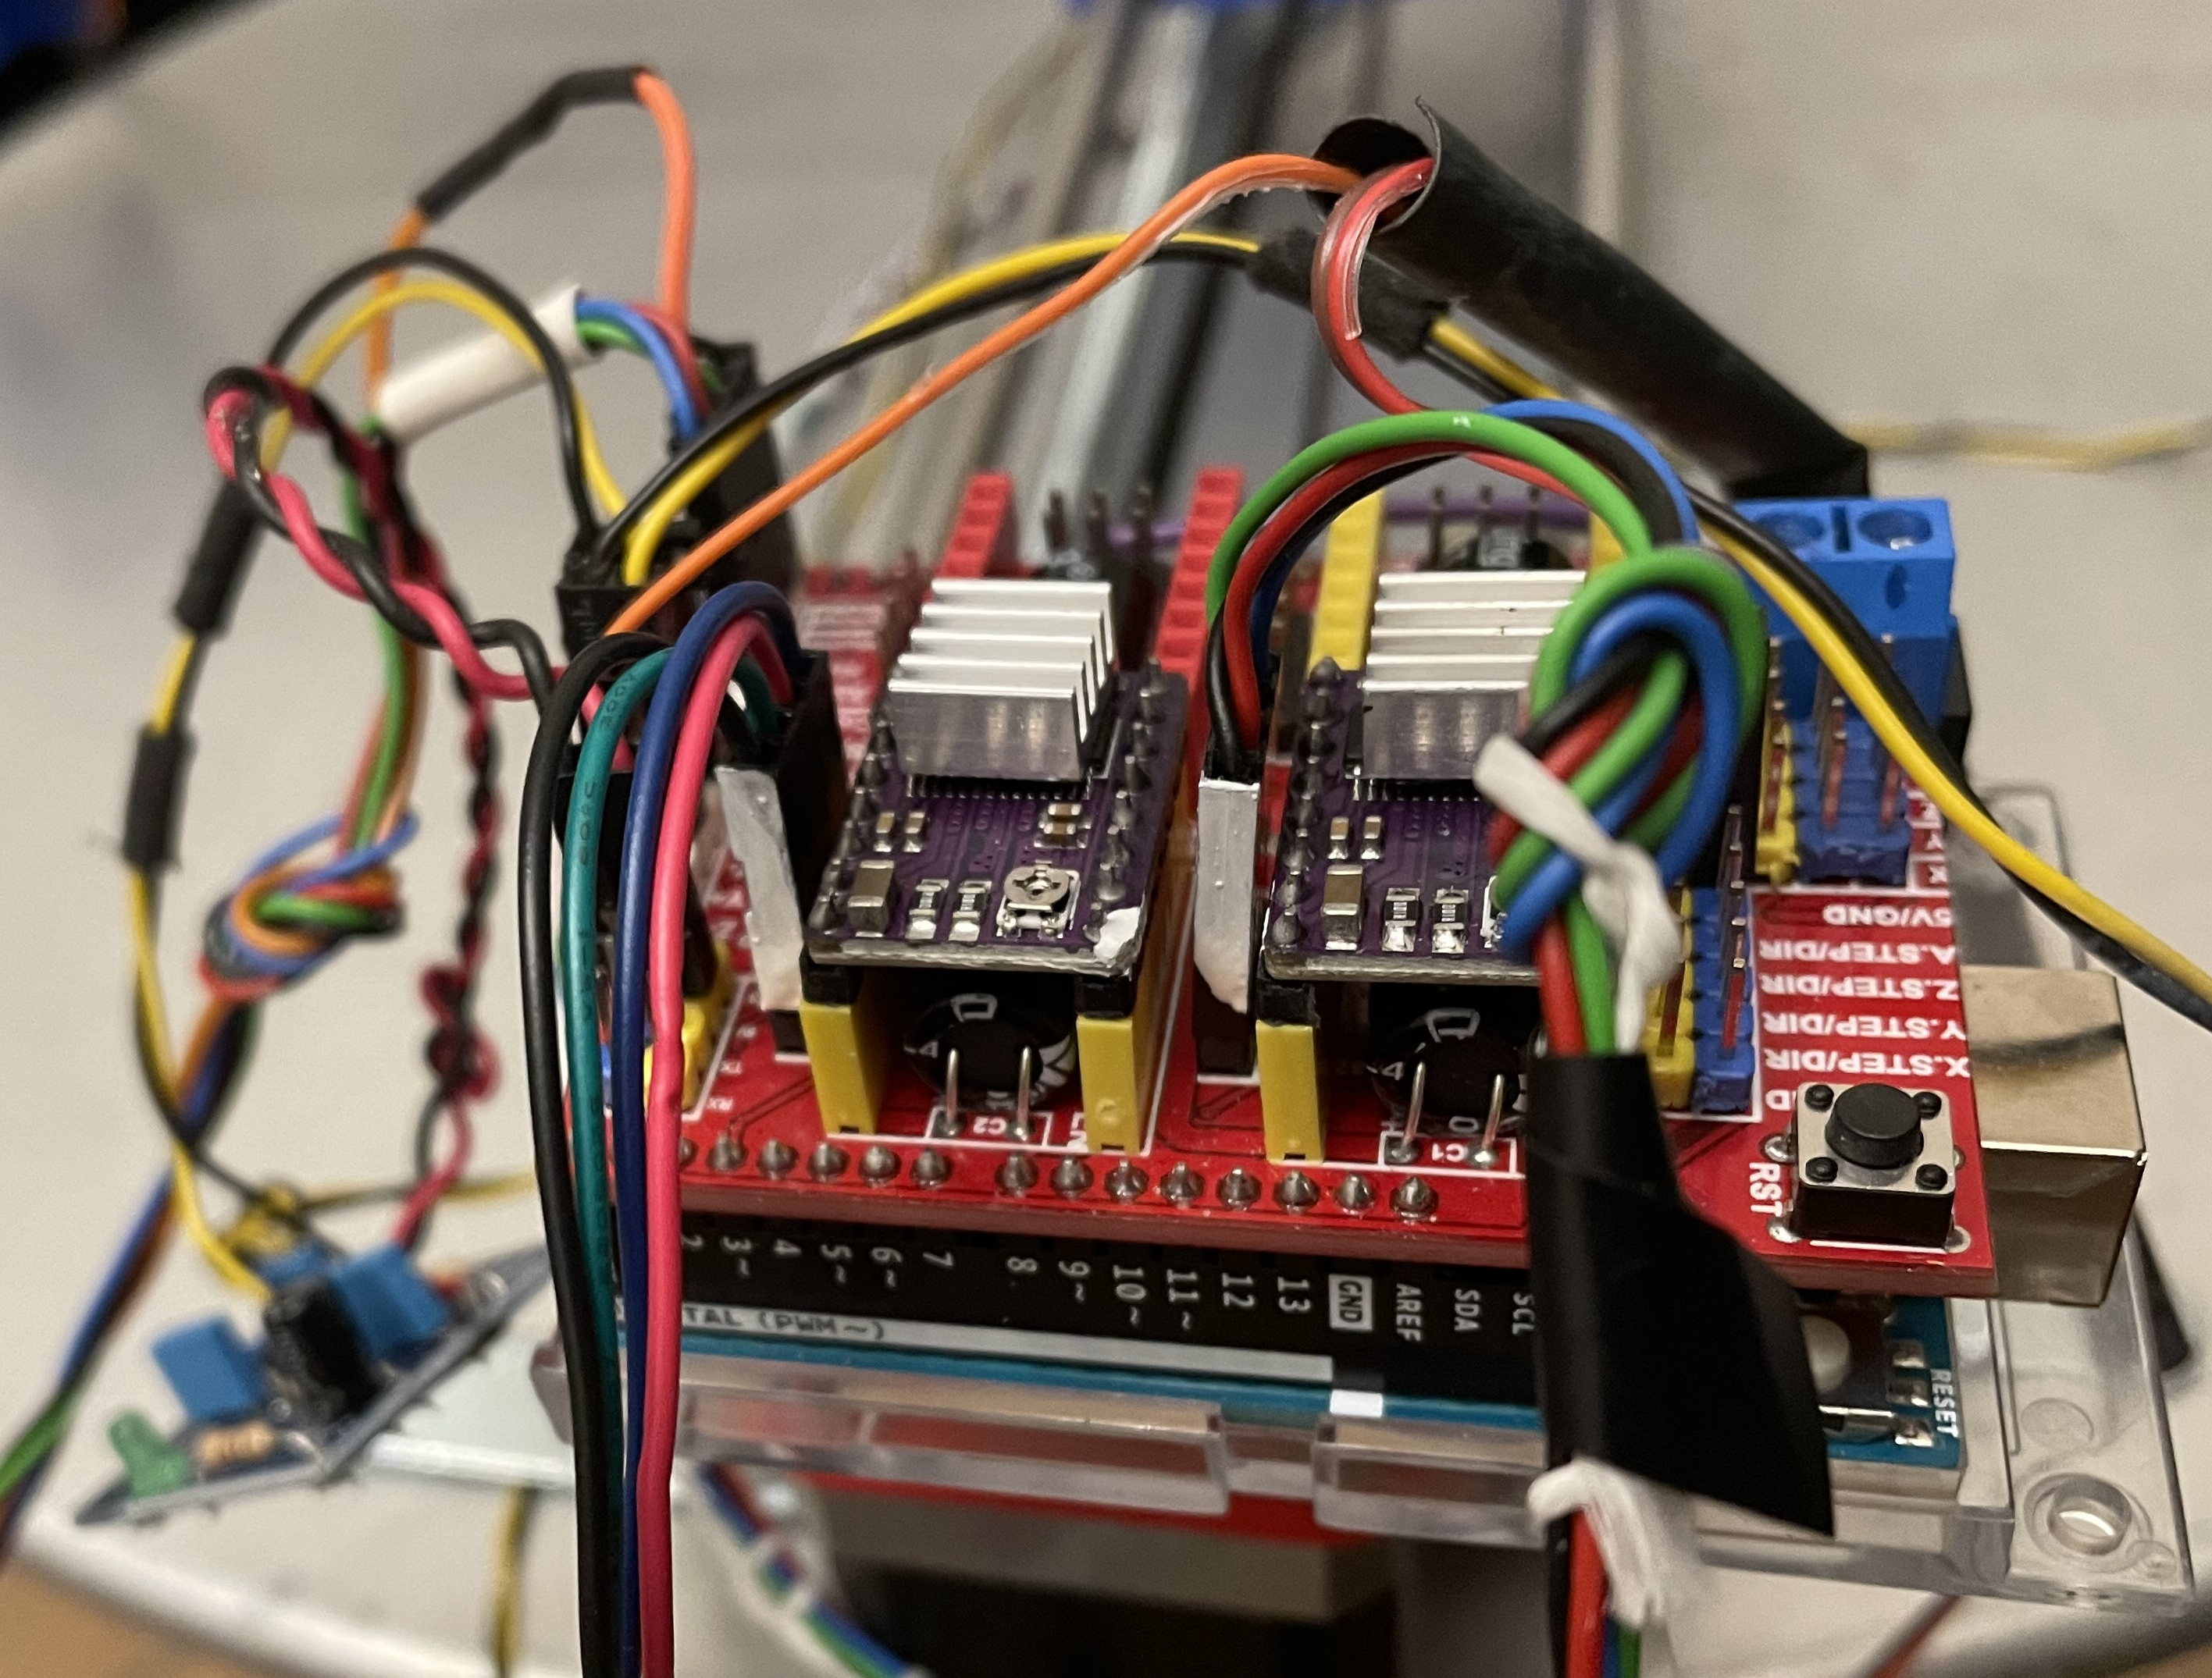

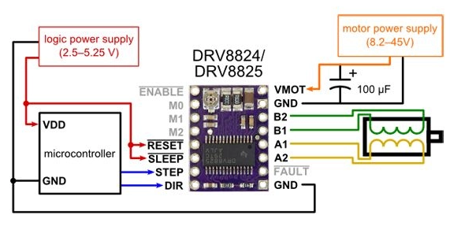
Motor Driver DRV8824 - DRV8825

V_{xREF}
Adjust maximum Motor current with:

Type | R_{sense} Ω
DRV8824 | 0,33
DRV8825 | 0,1
V_{xREF} maximum: 3,3v

Step Resolution Jumpers

- High Jumper is inserted
- Low Jumper is not inserted

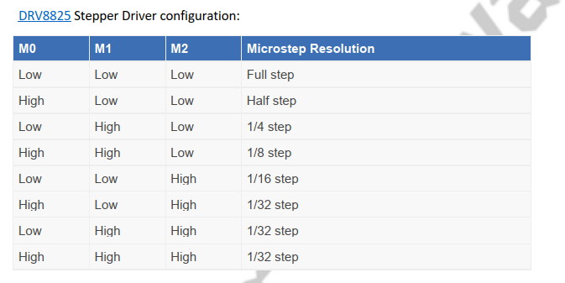

Servo

It is used for moving the pencil up or down.

A three-wire cable will be coming from the servo.
Servo cable has to go to (red) +5V, (black) GND and signal (white or brown) to Digital pin 11.
Commands
- M03 Sxxx (xxx between 0 and 255) to rotate the servo between 0-180.
- M05 turns the servo to zero degrees.

Servo program features

In the program, Servo is controlled by Spindle named functions.
The actual movement of the Servo, up or down depending on the G-Code, is made in file:
spindle_control.c
spindle_control.h

define RC_SERVO_SHORT 15 // Timer ticks for 0.6ms pulse duration (9 for 0.6ms)
define RC_SERVO_LONG 32 // Timer ticks for 2.5 ms pulse duration (39 for 2.5ms)
For having the servo working from 0 --> 180 degrees change RC_SERVO_SHORT and put 9, RC_SERVO_LONG and put 39
For inverted movement, uncomment the line
//#define RC_SERVO_INVERT 1 // Uncomment to invert servo direction

Limit Switches

Connections

Limits switches Stops generating an Alarm when movement exceeds limits.

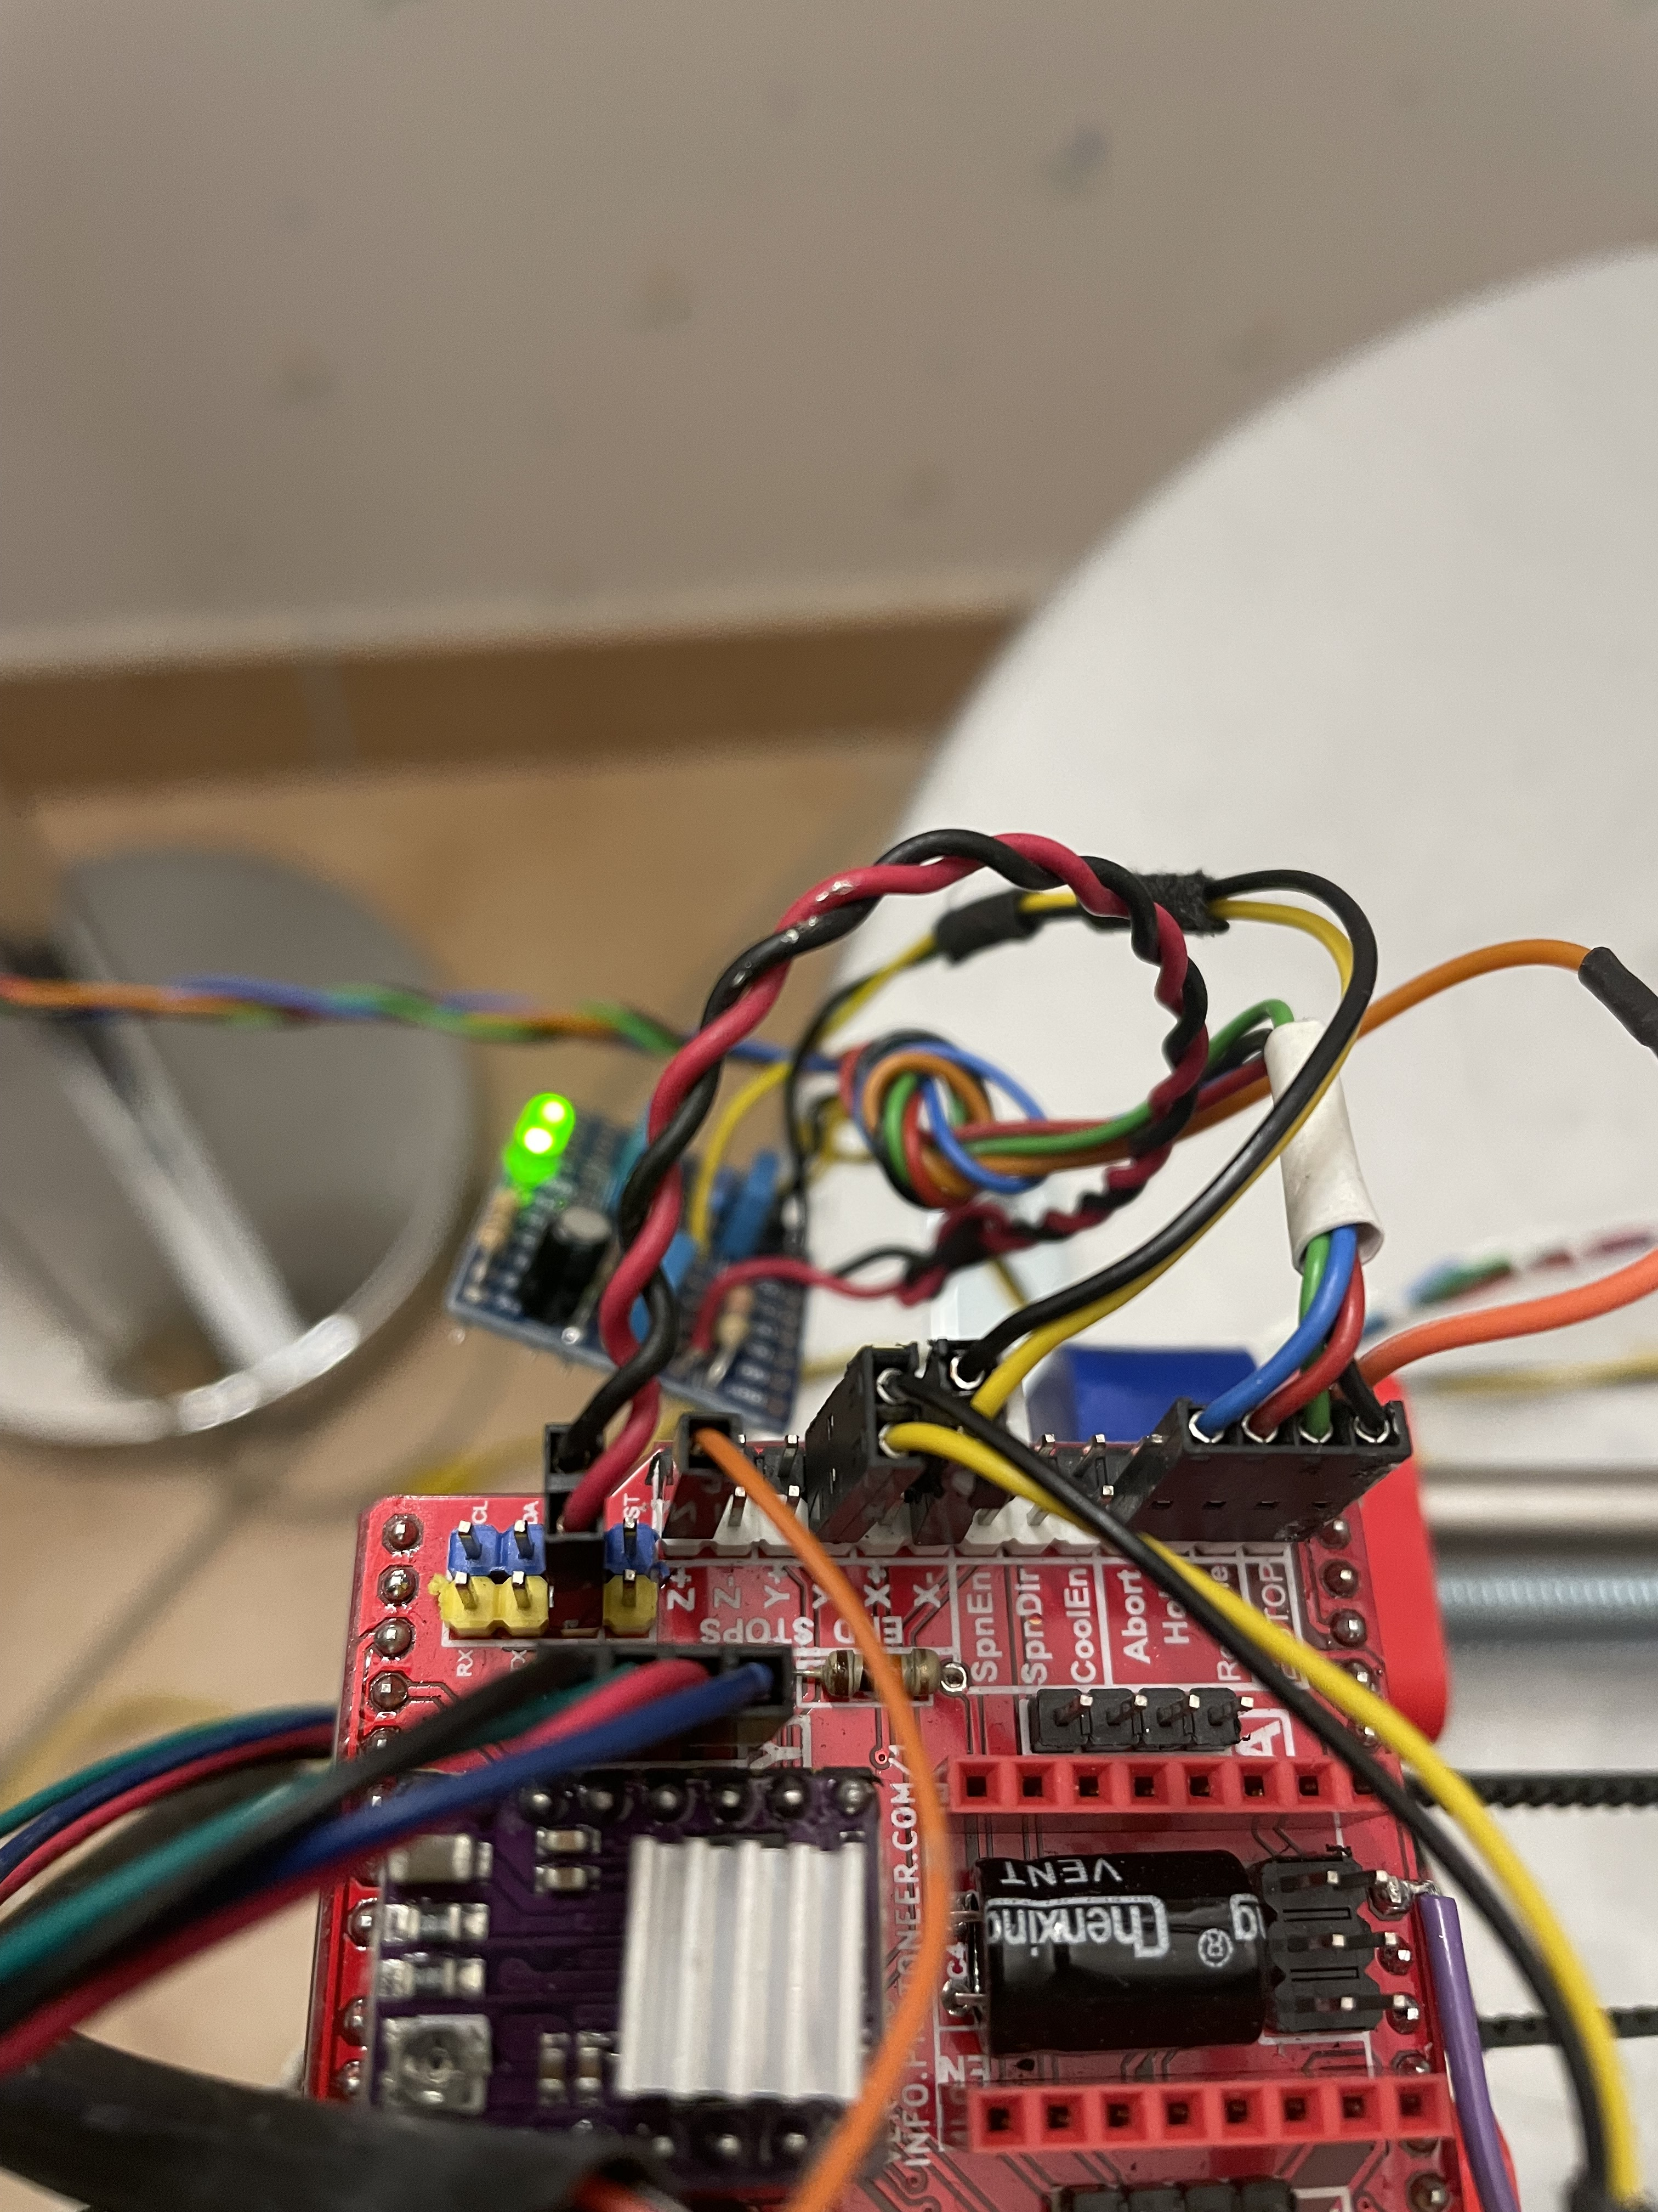
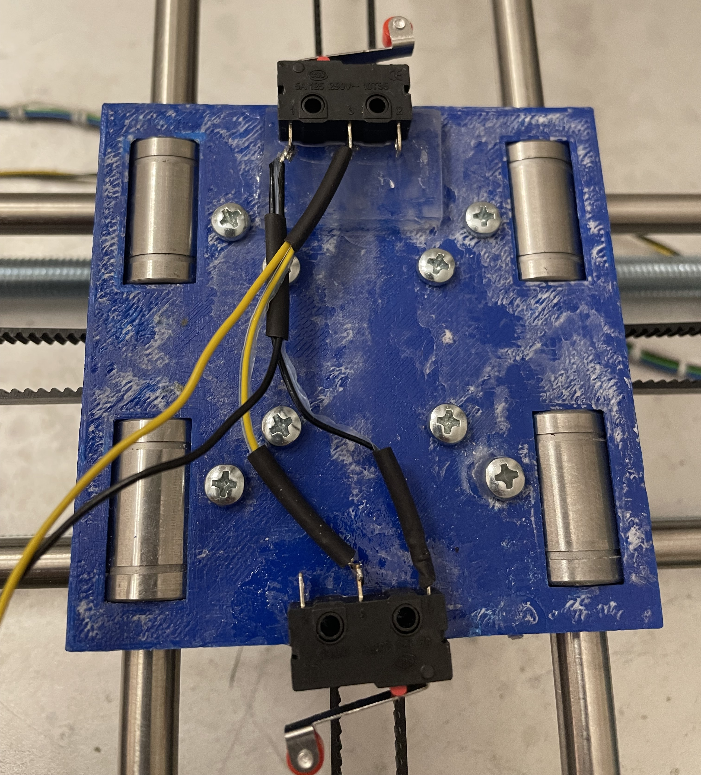
Y axis limits

X axis limits

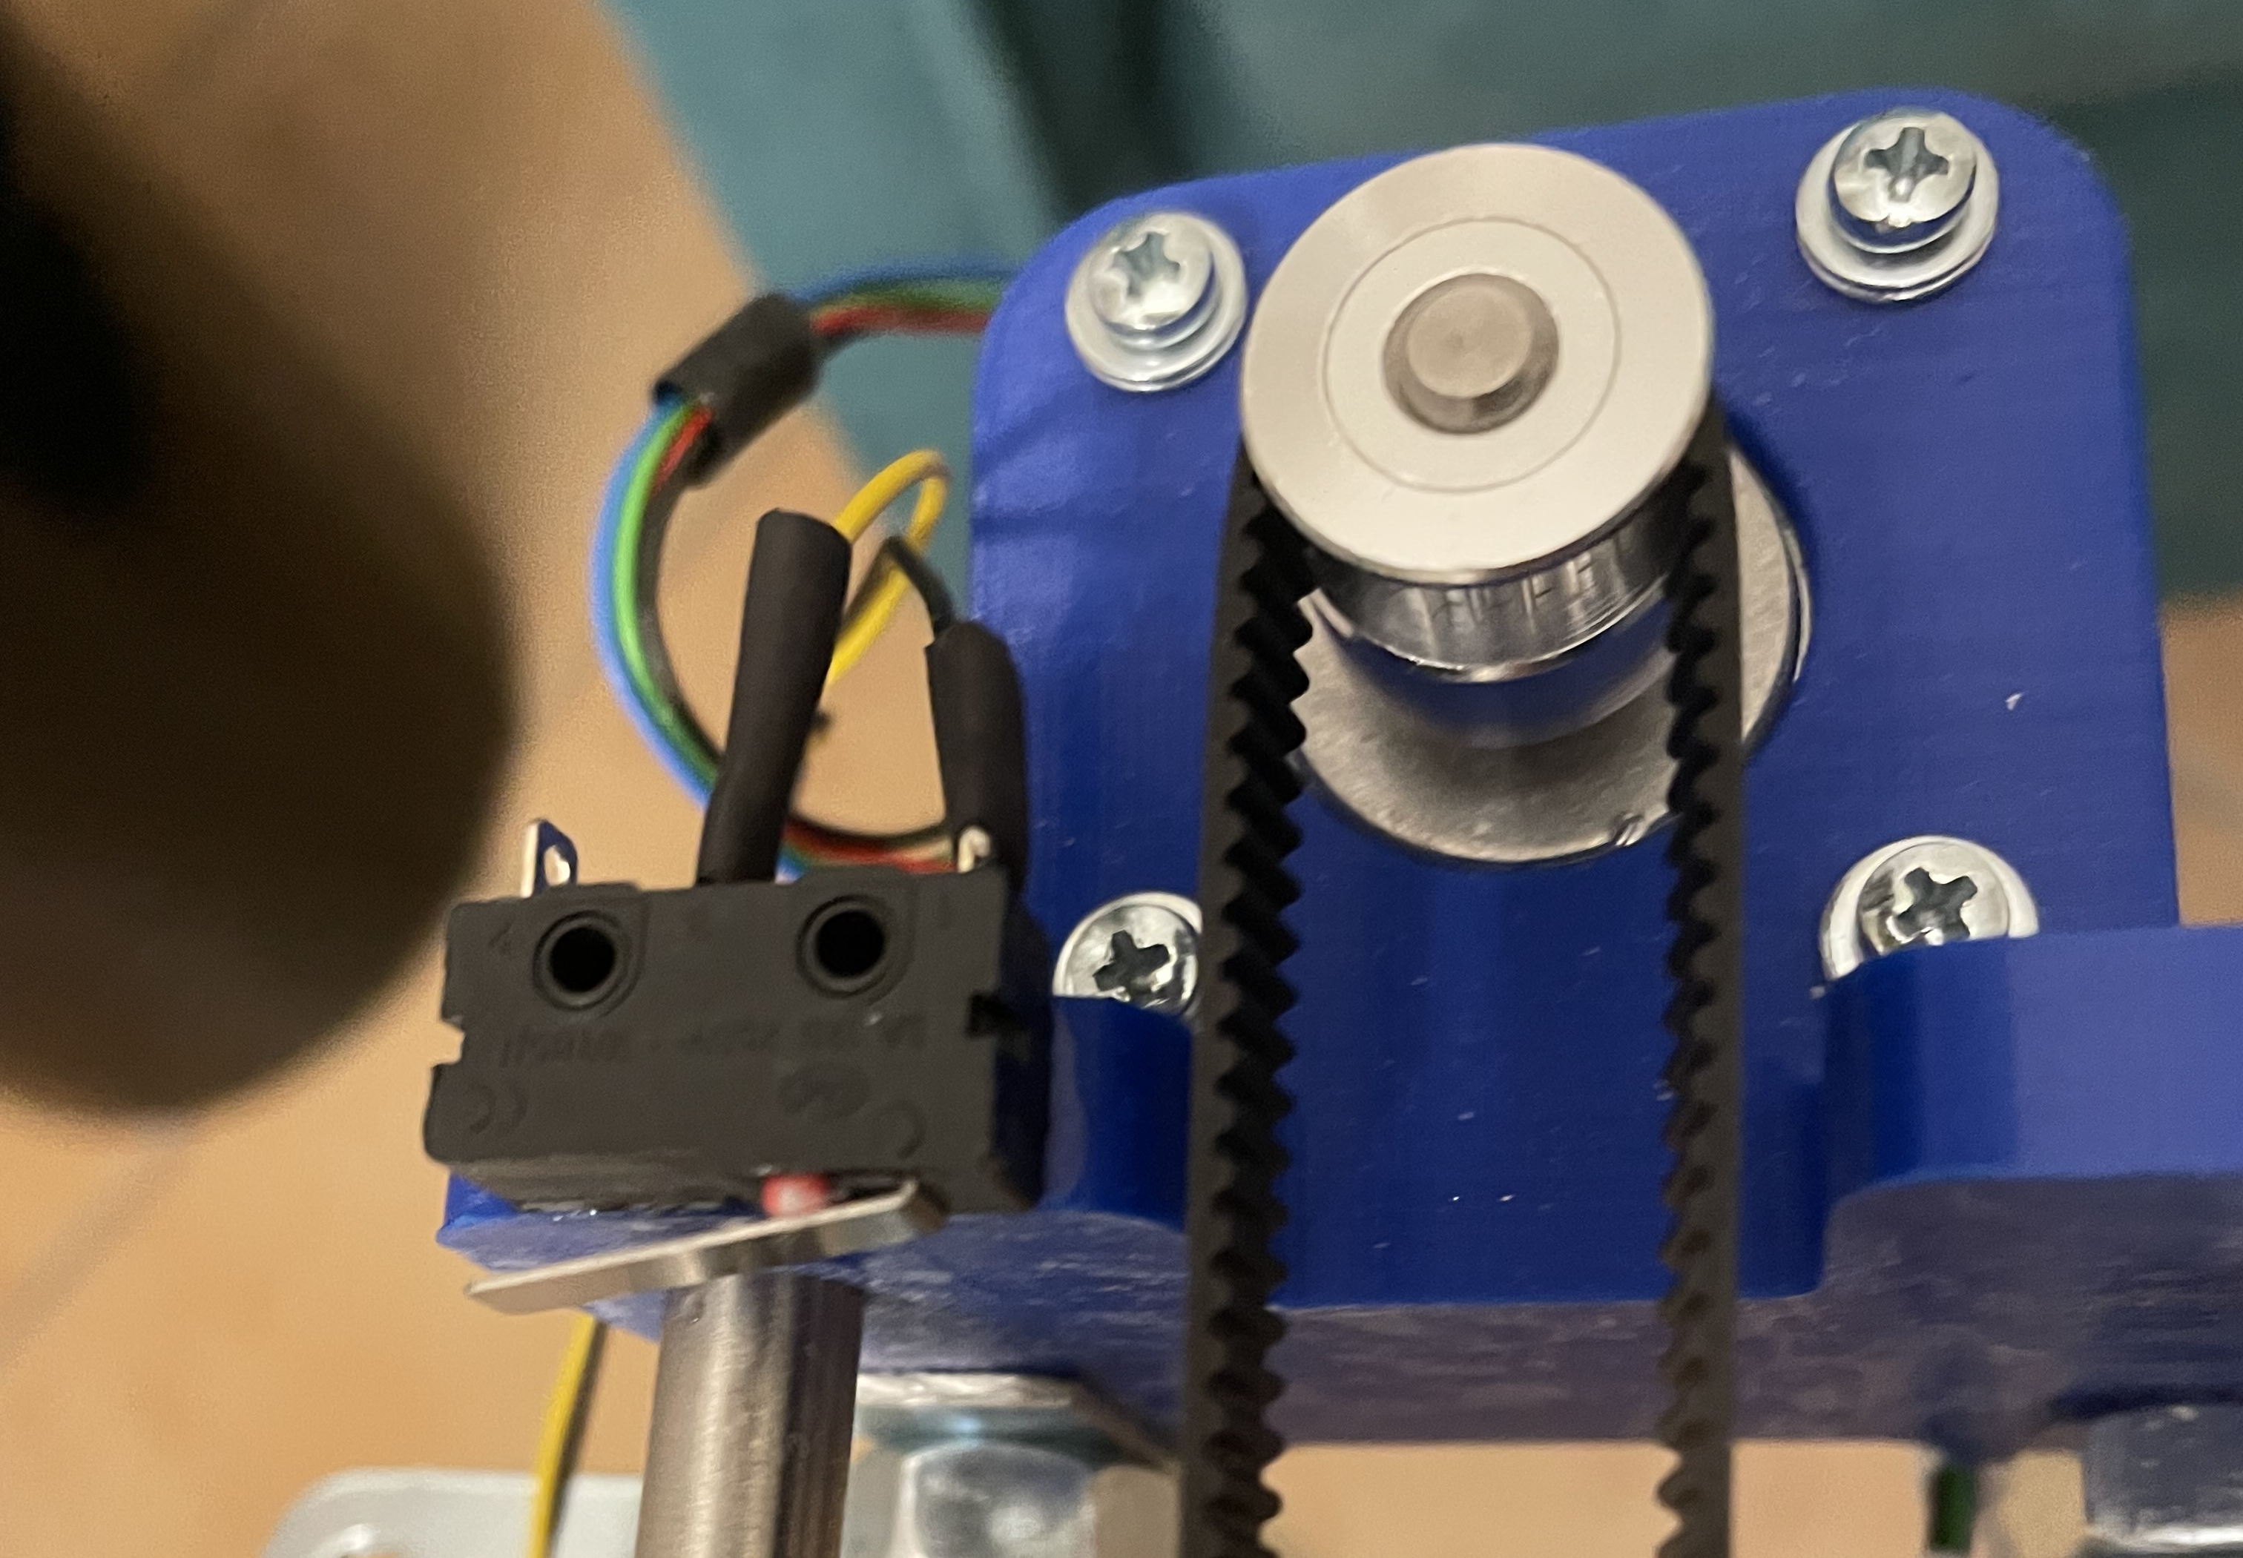
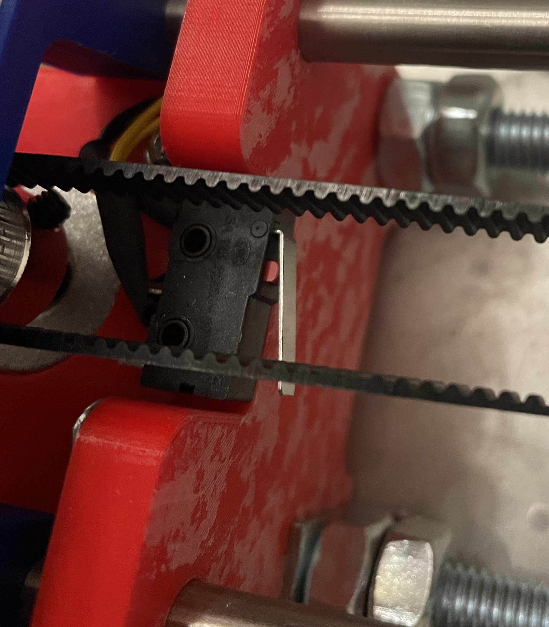

Filtering
Inputs are filtered before entering the Arduino for eliminating any spurious noise.
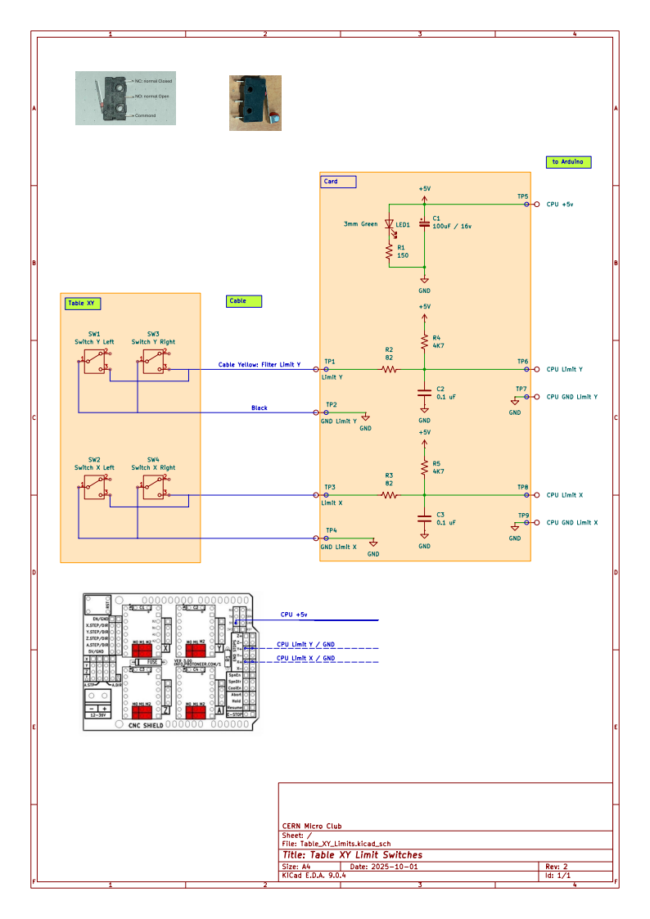

Push buttons

Connections

Button | Card Name | Cable colour | Description
E Stop | E | Black  Connector white mark | In parallel with Arduino Reset
Resume | R | Green | Resume printing (after Hold)
Hold | H | Red | Hold printing
Abort | A | Blue | Abort present printing
GND |  | Orange

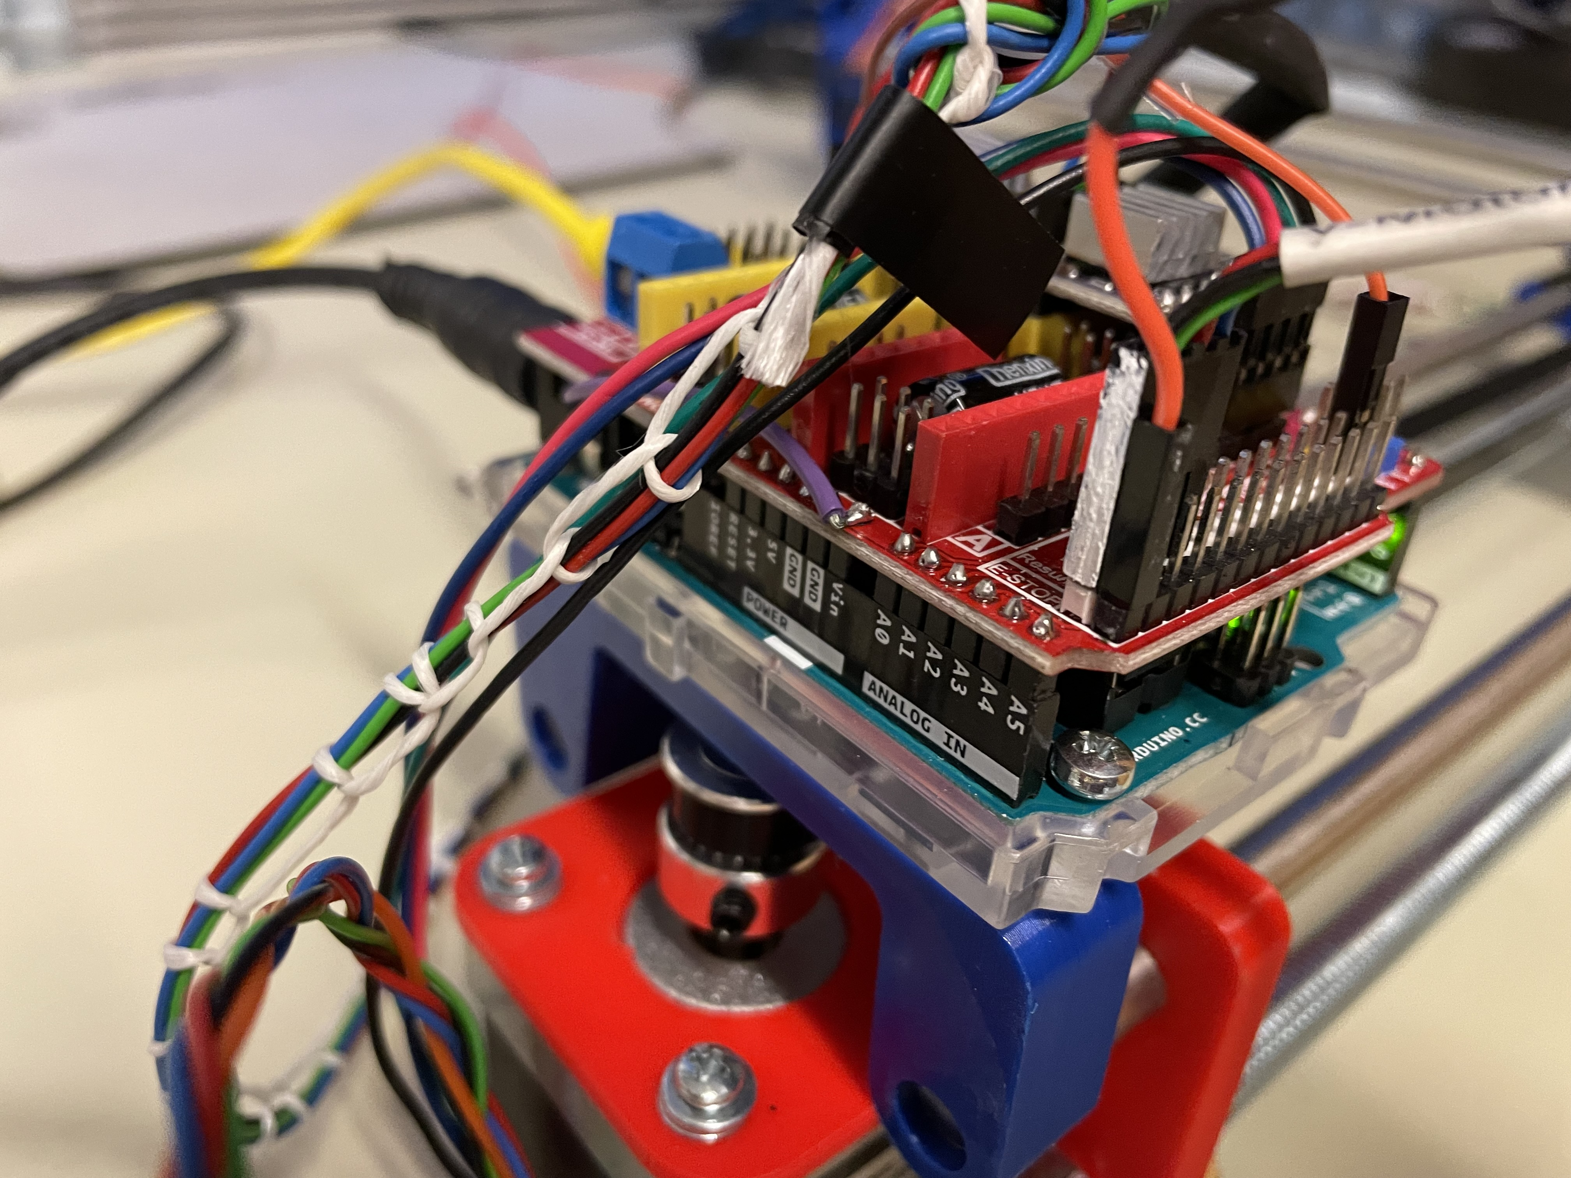
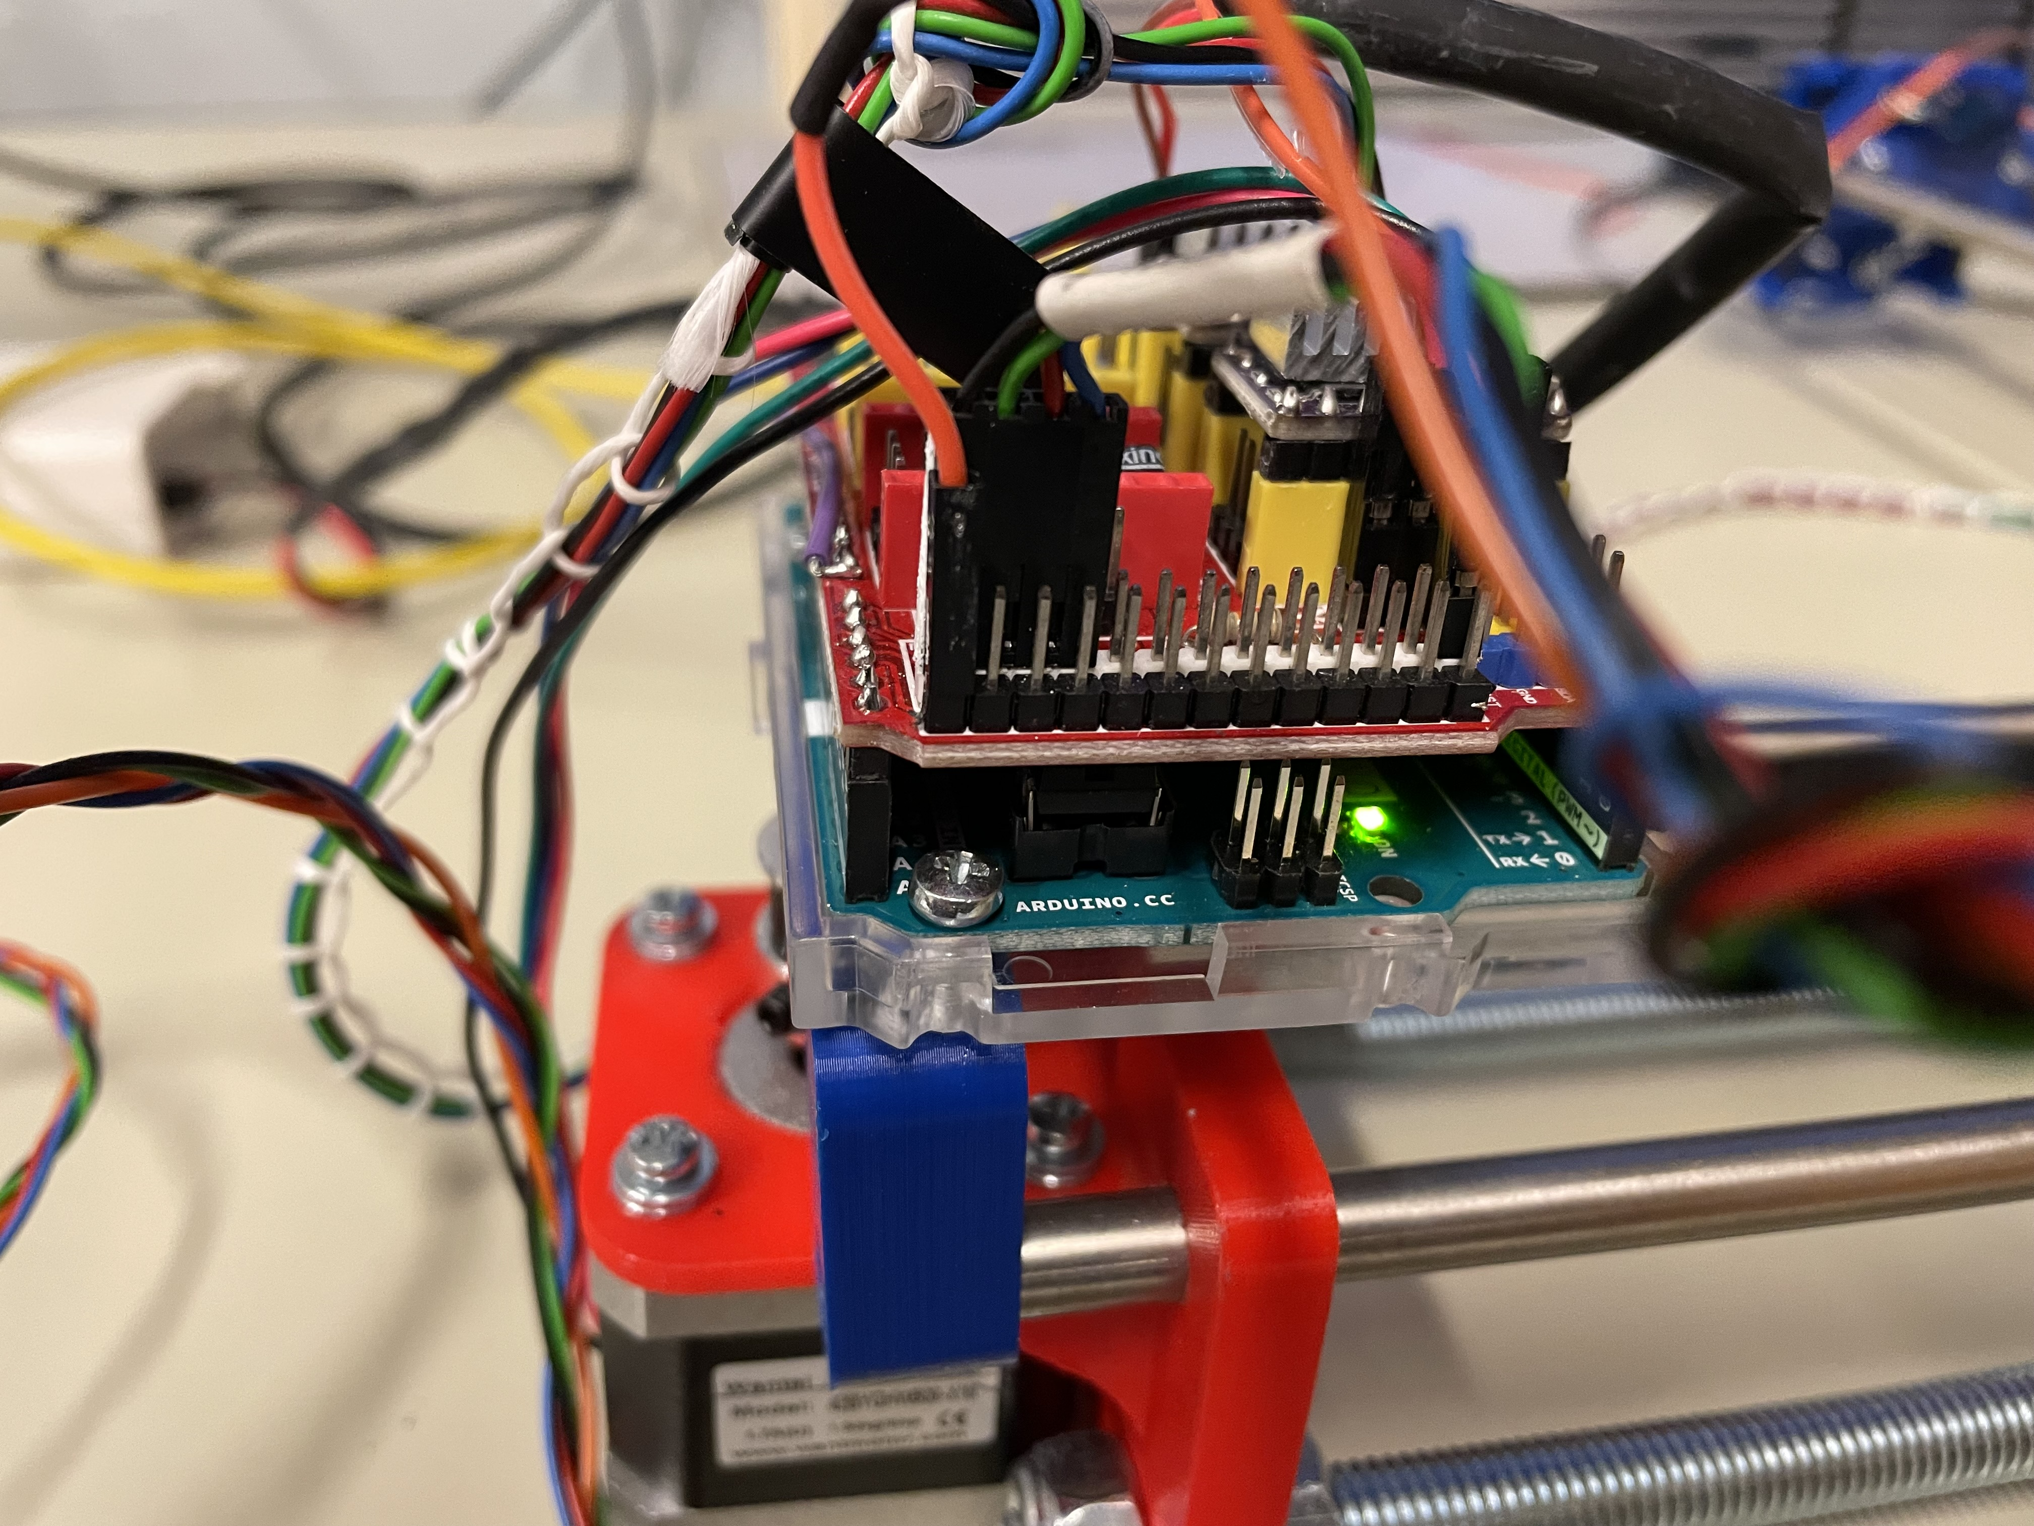
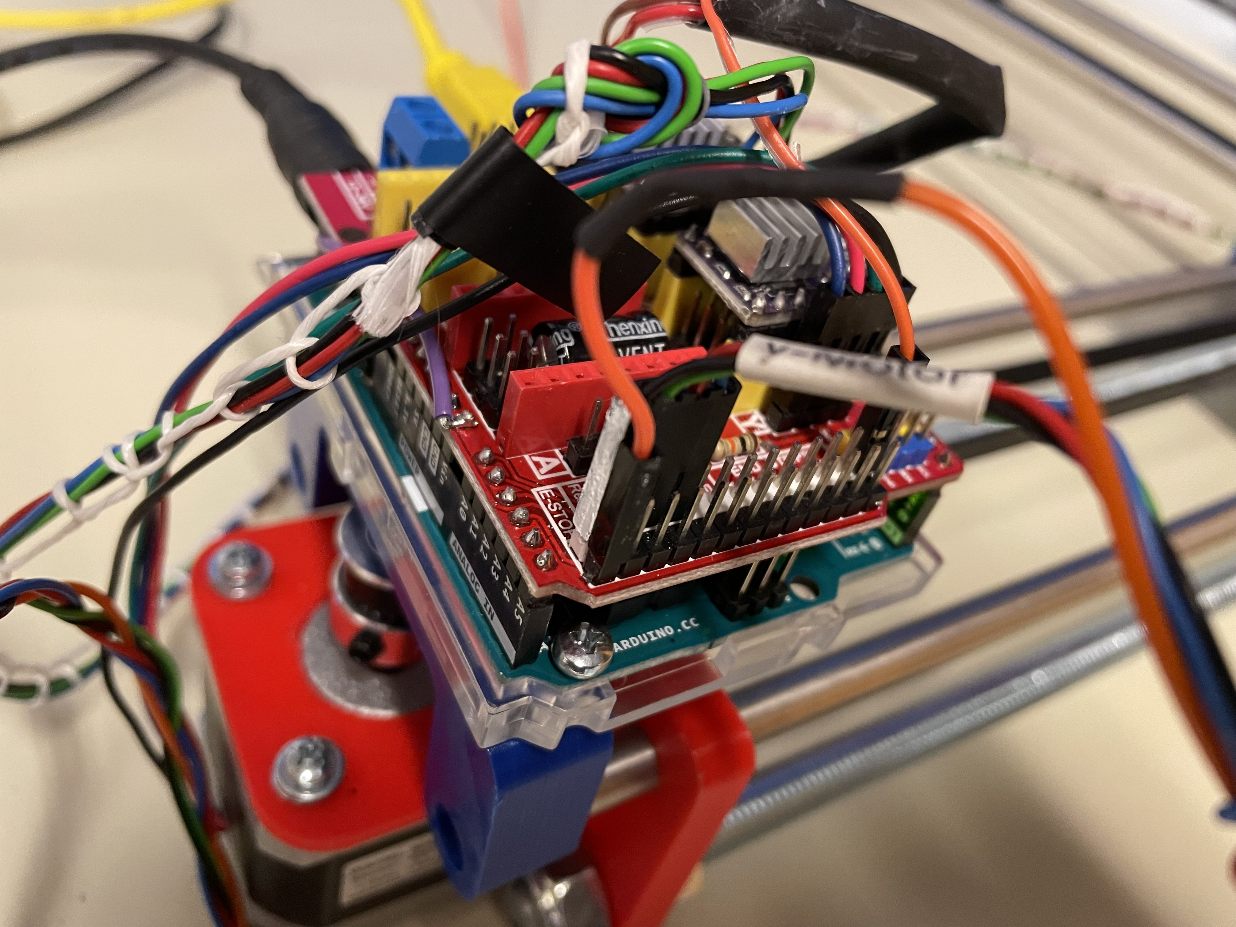

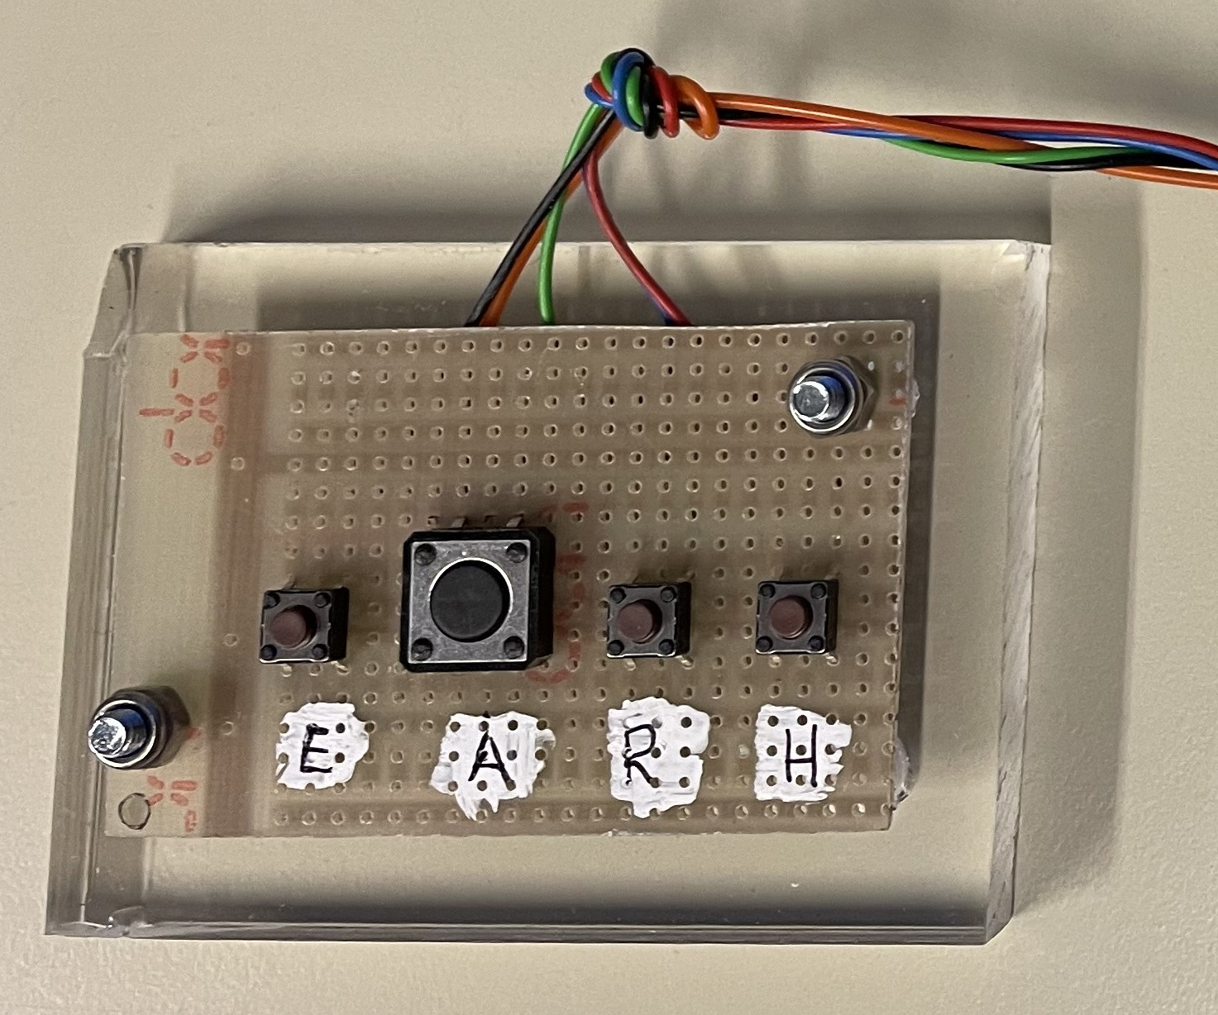
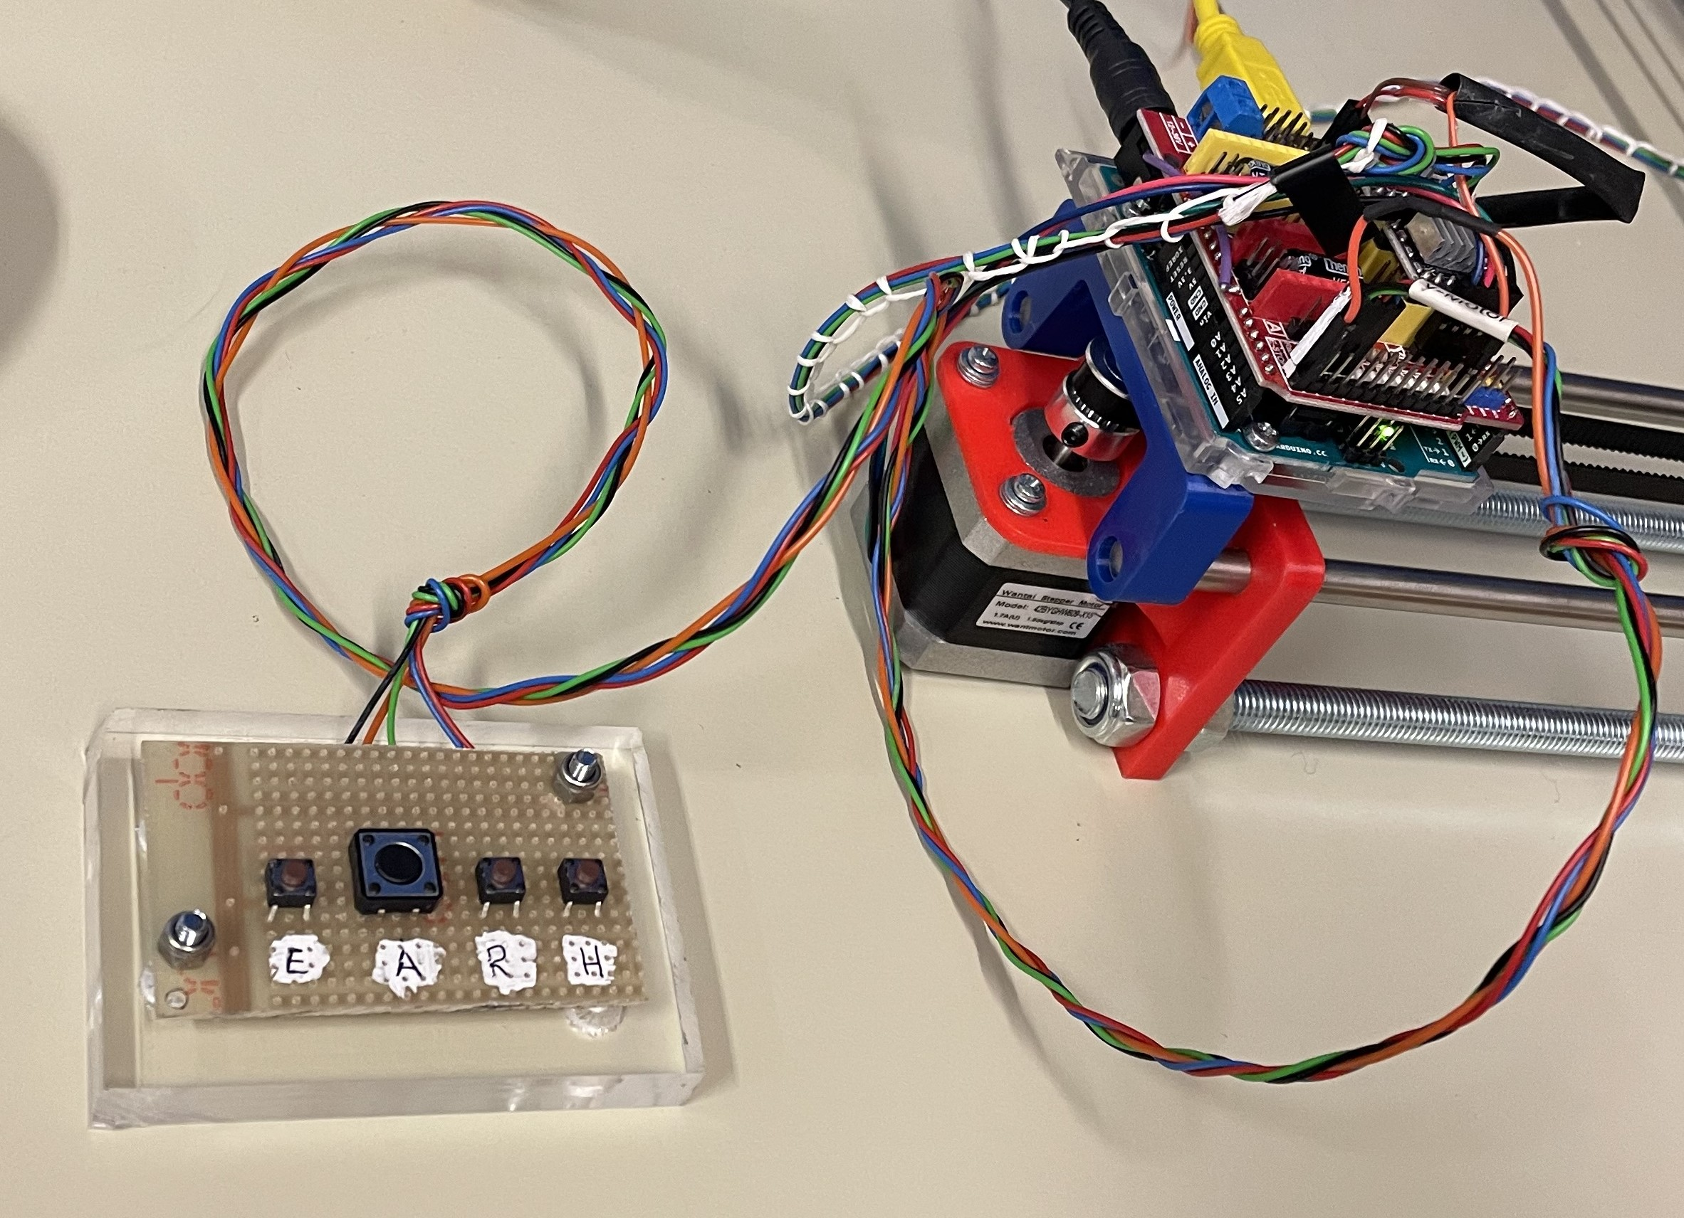
E Stop
Abort
Alarm
Resume
Hold

Actions

When HOLD is pressed, process continues after RESUME is pressed.
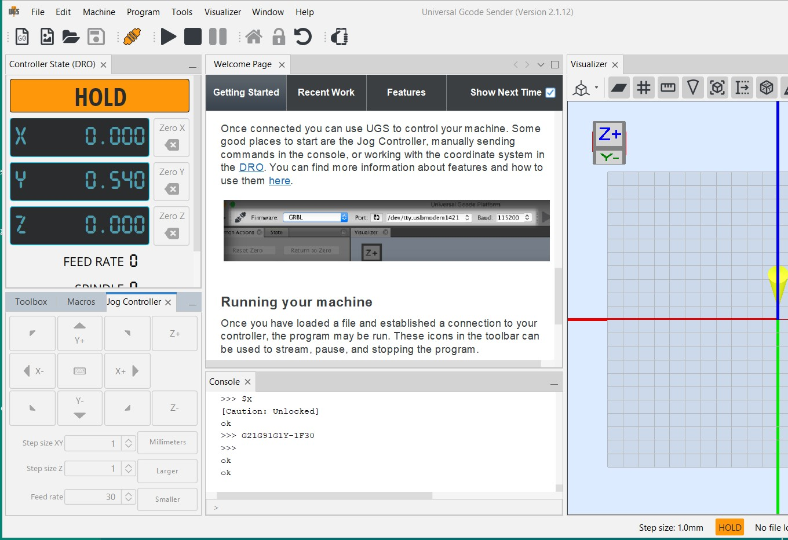

When ABORT is pressed:
- In UGcode-Sender toolbox click Unlock
or
- enter command $X in Console TX
- Then, status passes to IDLE

Note: $H is for Homing
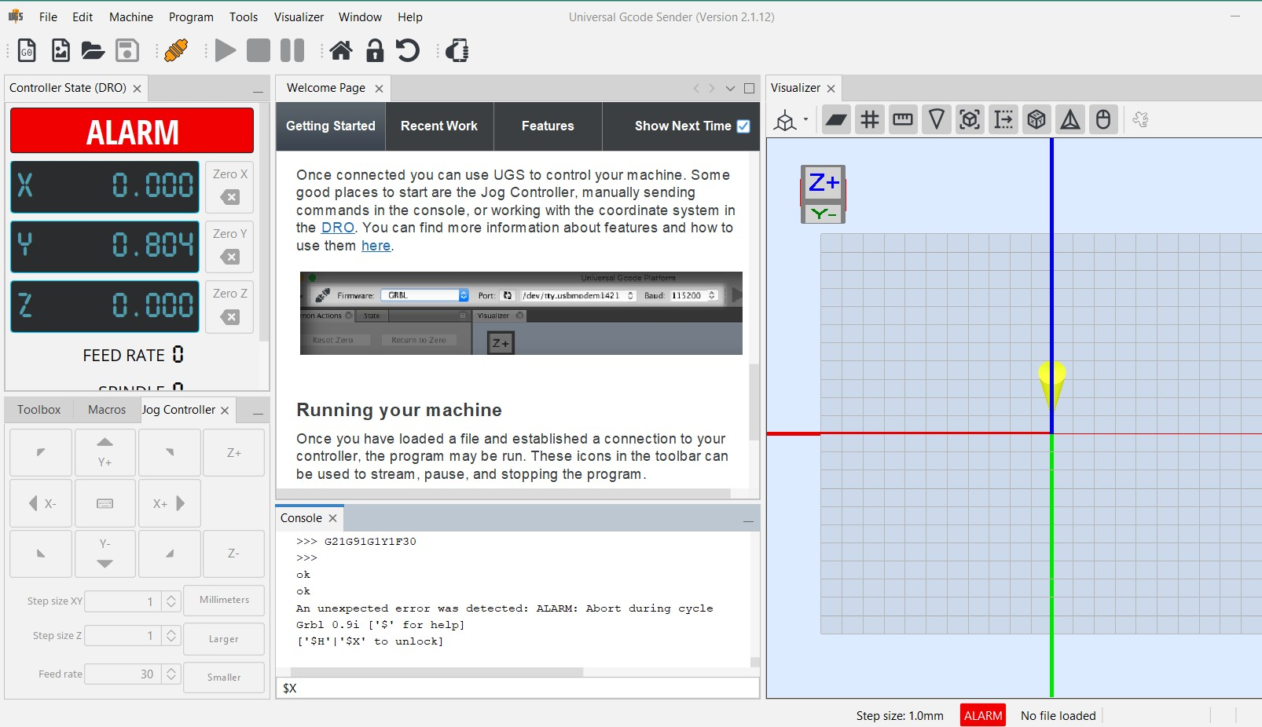
Console TX

Limit Switches
For protecting the Table XY from reaching the limits, Limit switches must be enabled

From the terminal (commands tab) of the Universal Gcode Sender, the settings of your firmware by typing $$
- Check the parameter $21 = 1

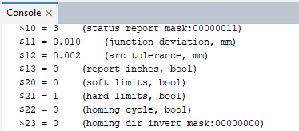

Enabling

Two ways:

- In UGcode-Sender Machine / Setup wizard set:

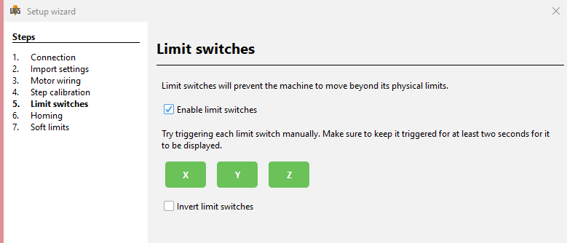
or
- From the terminal (commands tab) of the Universal Gcode Sender, the settings of your firmware by typing $$
  - Type “$21 = 1 + Enter” to enable.

Reached
When Limit Switch are reached:
- Press E Stop to reset and Reload the program
or
- In UGcode-Sender toolbox click Soft Reset, then, for unlocking and reloading
  - In UGcode-Sender toolbox click Unlock
or
  - enter command $X in Console TX
- Then, status passes to IDLE

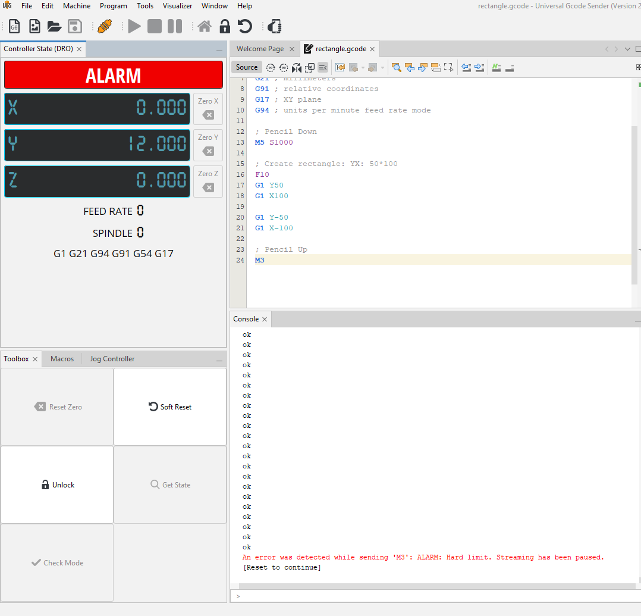

UGcode-sender

When process is abnormally stopped, Controller State coordinates / Visualizer indications stays unchanged, therefore they must be manually reset with Zero [X/Y/Z] buttons

Setting the Steps per mm
From the terminal (commands tab) of the Universal Gcode Sender, the settings of your firmware by typing $$
- Check the parameters $100 and $101. They define how many steps are required for the machine to go 1mm.
- Considering that you used a 200-step motor, a 20-tooth pulley, and the GT2 belt (2mm pitch), the correct values for both parameters would be 80.
- If they are not with these values, type “$100=80 + Enter” on the terminal to adjust the X axis. Type “$101 = 80 + Enter” to adjust the Y axis.

